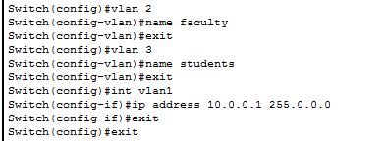

D:\UMAR\BUKC\5th Semester\DCN\Labs\Lab 6\2.PNG

D:\UMAR\BUKC\5th Semester\DCN\Labs\Lab 6\3.PNG

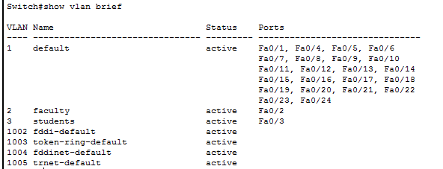

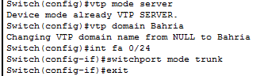

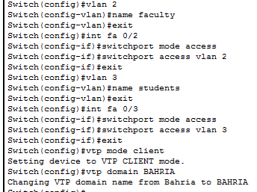

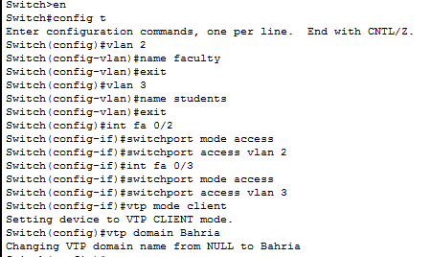

D:\UMAR\BUKC\5th Semester\DCN\Labs\Lab 6\8.PNG

ON DIFFERENT VLAN

ping 10.0.0.4

Pinging 10.0.0.4 with 32 bytes of data:

Request timed out.

Request timed out.

Request timed out.

Request timed out.

Ping statistics for 10.0.0.4Packets: Sent = 4, Received = 0, Lost = 4 (100% loss),